Create Launch Template

Add the AMI search as: ami-0ed9277fb7eb570c9

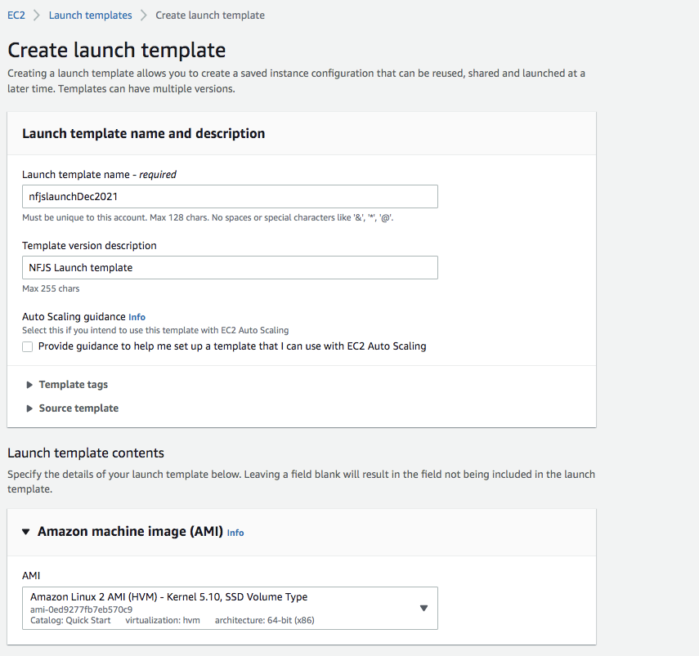

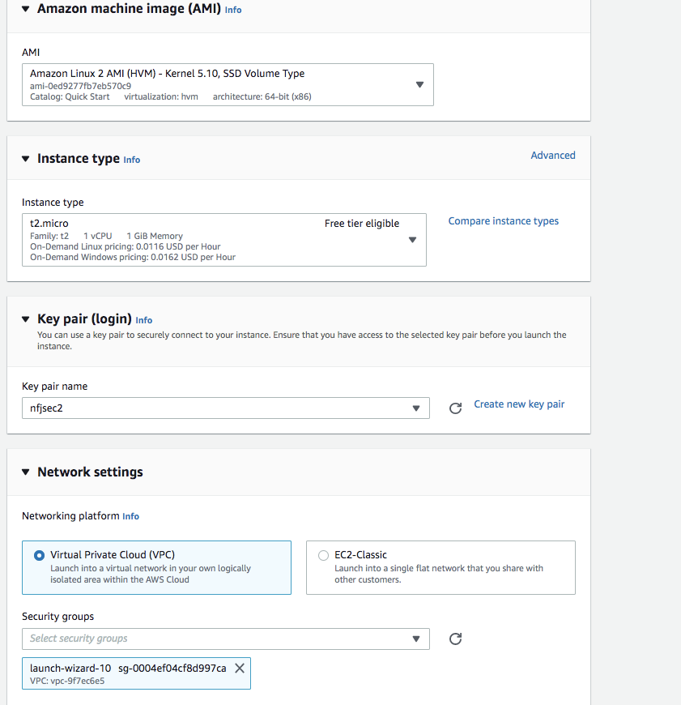

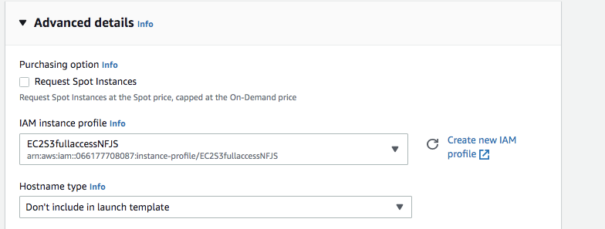

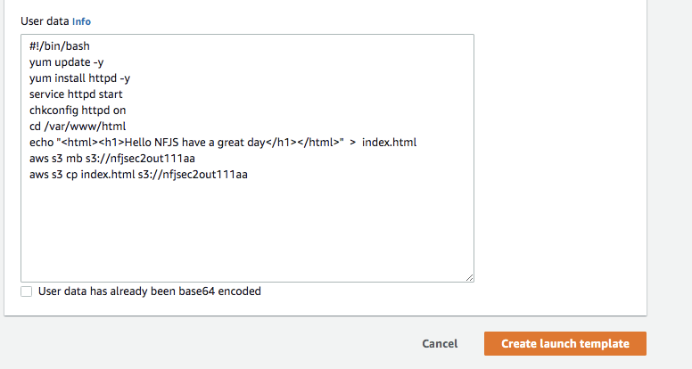

#!/bin/bash

yum update -y

yum install httpd -y

service httpd start

chkconfig httpd on

cd /var/www/html

echo "<html><h1>Hello NFJS Arch Conf Auto Scaling have a great day</h1></html>" > index.html

aws s3 mb s3://nfjsec2Dec20211asout111

aws s3 cp index.html s3://nfjsec2Dec20211asout111

# Create Autoscaling group

